Appendix A
Containing drawings for T-Joint mould tool. In order: Base plate, L plate 1, L plate 2, base spacer 1, base spacer 2, spacer 1, spacer 2 and cap.
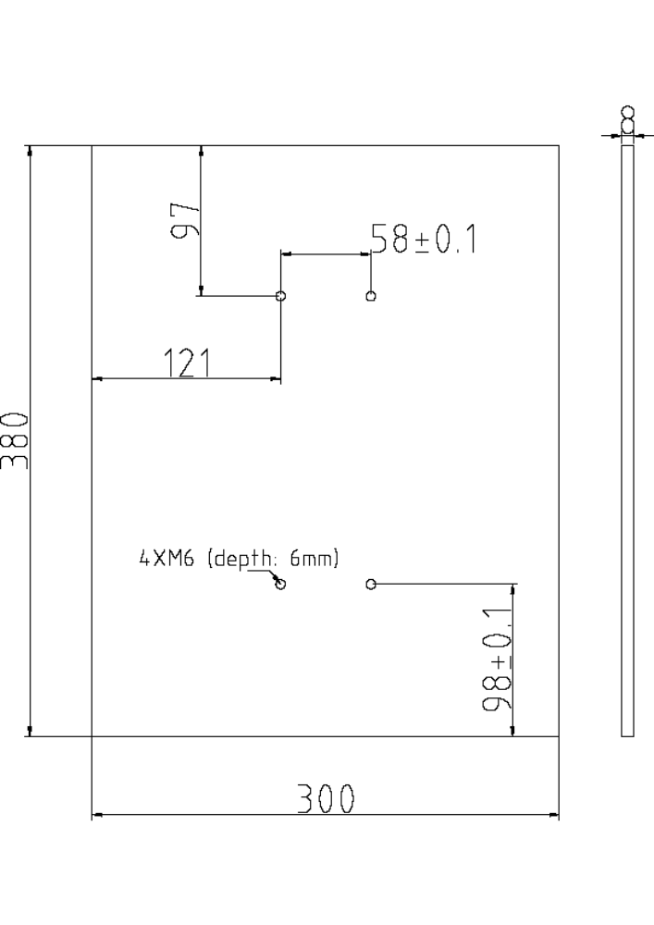
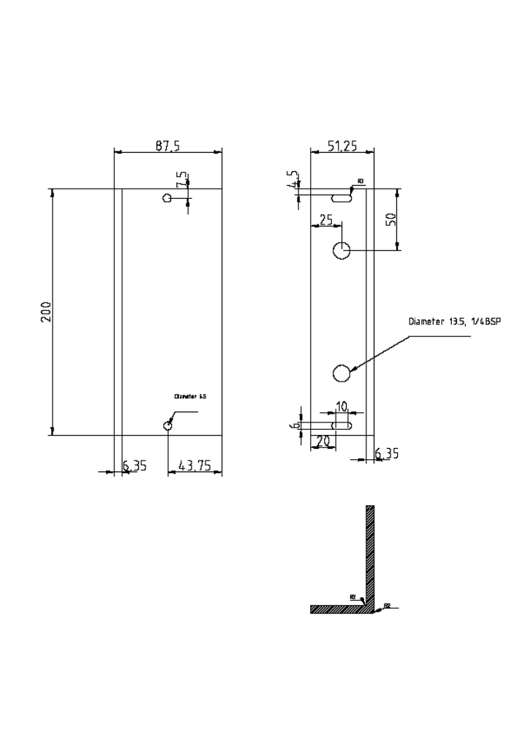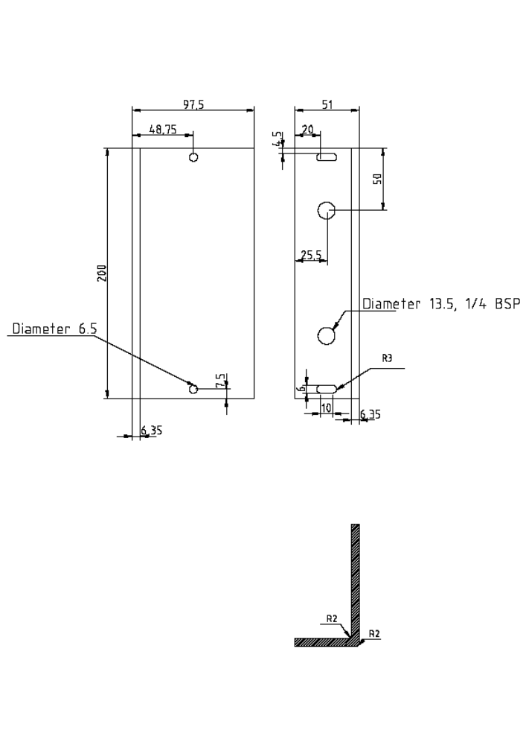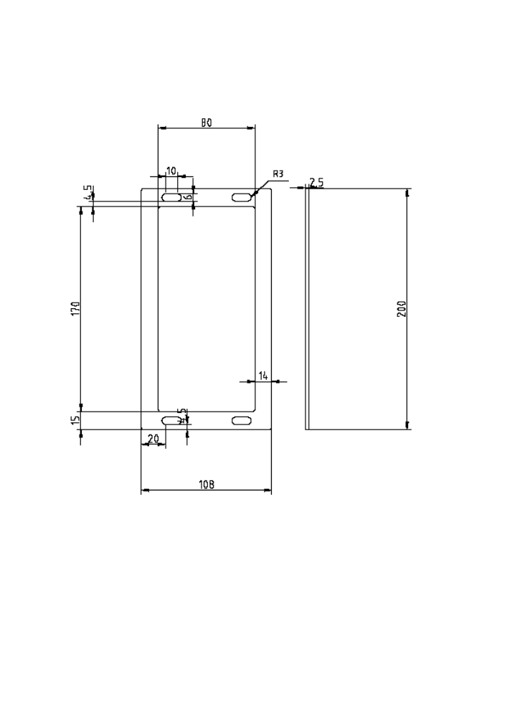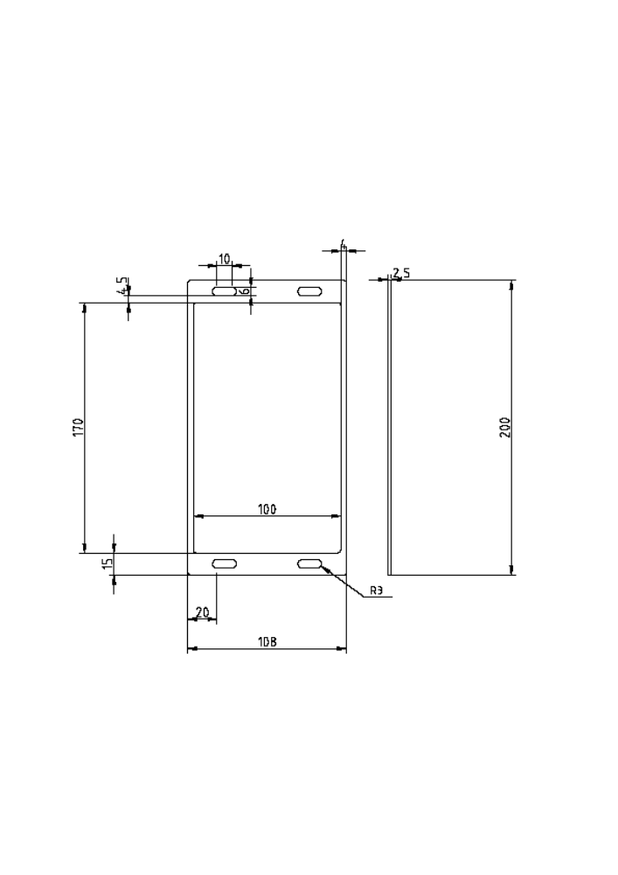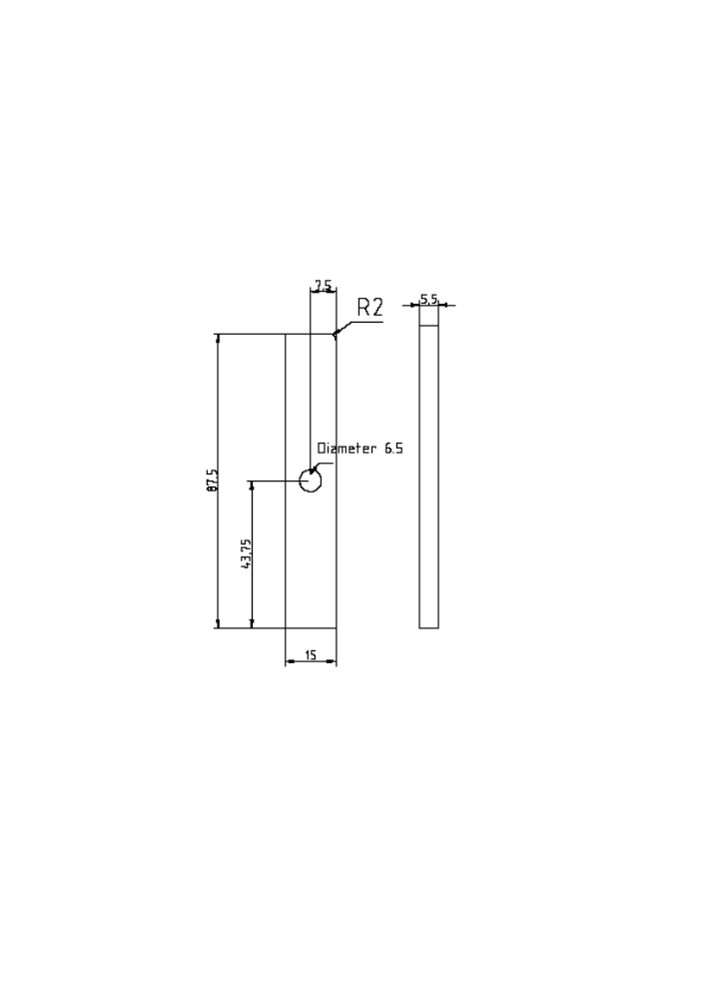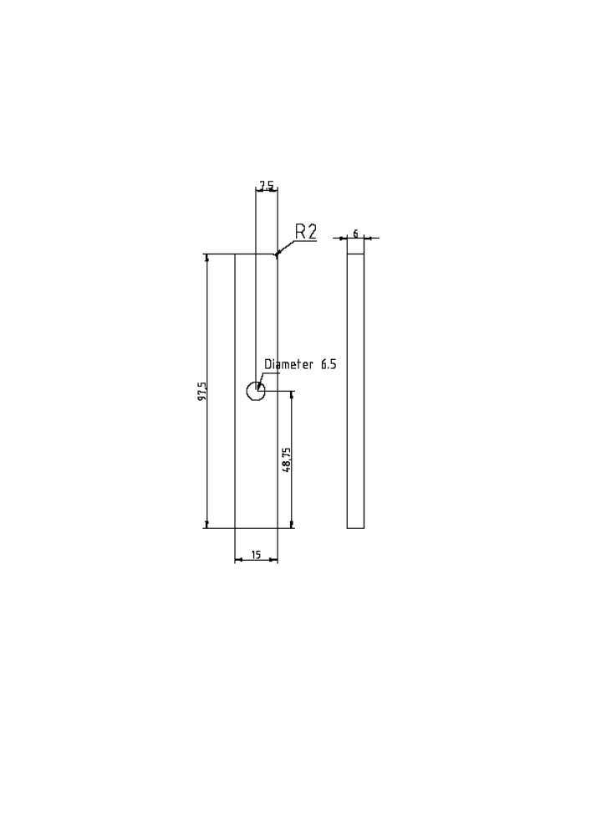

Appendix B
The code used in the work contained in this thesis is stored in the GitHub repository found at the following link.

https://github.com/georgespackman/PhDThesis

The version of TexGen used is present along with the Python code presented in chapters 4, 5 and 6.

